Business Practice Manual for
Rules of Conduct Administration

Version 5

Last Revised: October 4, 2011

Approval History
Approval Date: March 13, 2009
Effective Date: March 31, 2009
BPM Owner: Benik Der-Gevorgian
BPM Owner’s Title: Director, Market Services

Revision History

Version | PRR | Date | Description
5 | 474 | 10/04/2011 | Revisions related to the CAISO’s April 20, 2011 Compliance Filing which was made in response to FERC’s Compliance Order of January 2011. FERC issued their order July 5, 2011.
4 | 273 | 8/2/2010 | Revisions related to the CAISO’s February 18, 2010 compliance filing, which was made in response to FERC’s November 19, 2009 Order on Compliance Filing concerning the CAISO’s initial Order 719 compliance filing and PTB updates.
3 | 74 | 11/1/09 | Revisions related to Payment Acceleration. PRR 74
2 | 15 | 5/7/2009 | Revisions to implement CAISO’s April 28, 2009 compliance filing in response to FERC Order 719 regarding market monitoring unit roles.
1 |  | 3/13/2009 | Original version

TABLE OF CONTENTS
1. Introduction 4
1.1 Purpose of California ISO Business Practice Manuals 4
1.2 Purpose of this Business Practice Manual 5
1.3 References 6
1.4 Acronyms & Specialized Terms 6
2. Overview of Rules of Conduct 7
2.1 Rules of Conduct Summary 7
2.2 Summary of Behavior Subject to Sanction 7
3. CAISO Administration Procedures for Rules of Conduct 9
3.1 Overview 9
3.2 Monitoring & Initial Review 10
3.2.1 Referrals to FERC 11
3.3 Investigation 13
3.3.1 Conducting Investigation 14
3.3.2 Notice of Investigation 14
3.3.3 Information Requests 15
3.3.4 Time Limitation 16
3.3.5 Decision Regarding Violation and Notice 16
3.4 Sanction Administration 16
3.4.1 Determination of Sanctions 18
3.4.2 Notification of Affected Parties 19
3.4.3 FERC Review of Enhanced Penalties 20
3.4.4 Settlement 20
3.4.5 Disposition of Sanction Proceeds 23
3.5 Record Keeping 25

List of Exhibits:
Exhibit 1-1: CAISO BPMs 4
Exhibit 3-1: Overview of DMM Process 10
Exhibit 3-2: Monitoring & Initial Review Process 12
Exhibit 3-3: Investigation Process 15
Exhibit 3-4: Sanction Administration Process 19

Introduction
Welcome to CAISO BPM for Rules of Conduct Administration. In this Introduction you will find the following information:
- The purpose of CAISO BPMs
- What you can expect from this CAISO BPM
- Other CAISO BPMs or documents that provide related or additional information

Purpose of California ISO Business Practice Manuals
The Business Practice Manuals (BPMs) developed by CAISO are intended to contain implementation detail, consistent with and supported by the CAISO Tariff, including: instructions, rules, procedures, examples, and guidelines for the administration, operation, planning, and accounting requirements of CAISO and the Markets. Each Business Practice Manual is posted in the BPM Library at: http://bpmcm.caiso.com/Pages/BPMLibrary.aspx. Updates to all BPMs are managed in accordance with the change management procedures included in the BPM for Change Management.

Purpose of this Business Practice Manual
The CAISO BPM for Rules of Conduct Administration describes how CAISO administers the Rules of Conduct for participating in CAISO Markets.
Although this BPM is primarily concerned with the Rules of Conduct, which can be found in Section 37 of the CAISO Tariff, there is some overlap with other BPMs. Where appropriate, the reader is directed to the other BPMs for additional information.
The provisions of this BPM are intended to be consistent with the CAISO Tariff. If the provisions of this BPM nevertheless conflict with the CAISO Tariff, the CAISO is bound to operate in accordance with the CAISO Tariff. Any provision of the CAISO Tariff that may have been summarized or repeated in this BPM is only to aid understanding. Even though every effort will be made by CAISO to update the information contained in this BPM and to notify Market Participants of changes, it is the responsibility of each Market Participant to ensure that he or she is using the most recent version of this BPM and to comply with all applicable provision of the CAISO Tariff.
A reference in this BPM to the CAISO Tariff, a given agreement, any other BPM or instrument, is intended to refer to the CAISO Tariff, that agreement, BPM or instrument as modified, amended, supplemented or restated.
The captions and headings in this BPM are intended solely to facilitate reference and not to have any bearing on the meaning of any of the terms and conditions of this BPM.

References
Other reference information related to this BPM includes:
- Other CAISO BPMs.
- CAISO Tariff, in particular Section 37, Rules of Conduct.
- Policy Statement on Market Monitoring Units, FERC, Docket PL05-1-000, 5/27/2005.
- FERC Code of Federal Regulations Market Behavior Rules, 18 C.F.R. § 35.37, and Prohibition of Electric Energy Market Manipulation, 18 C.F.R. § 1c.2.
- Order 719, FERC, Docket ER09-1048, 10/17/2008.

Acronyms & Specialized Terms
The definition of acronyms and words beginning with capitalized letters are given in the BPM for Definitions & Acronyms.

Overview of Rules of Conduct
Welcome to the Overview of Rules of Conduct section of the CAISO BPM for Rules of Conduct Administration. In this section you will find the following information:
- Summary of the CAISO Tariff Rules of Conduct.
- Summary of behavior that is subject to Sanction under the CAISO Tariff Rules of Conduct (CAISO Tariff Section 37).

Rules of Conduct Summary
CAISO Tariff Section 37.1, Objectives Definition and Scope
The Rules of Conduct, which can be found in the CAISO Tariff Section 37, are intended to provide fair notice to Market Participants of the conduct expected of them, to provide an environment in which all parties may participate on a fair and equal basis, to redress instances of market manipulation and other instances of anticompetitive behavior, and thereby to foster confidence of Market Participants, ratepayers and the general public in the proper functioning of the CAISO Markets.
At a high level, the Rules of Conduct are as follows:
- “Comply with Operating Orders” (CAISO Tariff Section 37.2).
- “Submit Feasible Energy Bids, RUC Capacity Bids, Ancillary Service Bids, and Submissions to Self-Provide” (CAISO Tariff Section 37.3).
- “Comply with Availability Reporting Requirements” (CAISO Tariff Section 37.4).
- “Provide Factually Accurate Information” (CAISO Tariff Section 37.5).
- “Provide Information Required by CAISO Tariff” (CAISO Tariff Section 37.6).

Summary of Behavior Subject to Sanction
As a general rule, the CAISO investigates and administers associated Sanctions for violations of the Rules of Conduct that can be objectively determined and for which pre-determined Sanctions are established in the CAISO Tariff. Where the particular circumstances of a potential violation preclude an objective determination that a violation occurred, the CAISO refers the matter to the Federal Energy Regulatory Commission (FERC). Conduct that potentially violates the Rules of Conduct which FERC administers include the failure to comply with orders, the failure to start and bring on line a Resource Adequacy Resource , the failure to undertake operating and maintenance procedures necessary to avoid a major Outage, and the failure to submit bids from resources that are reasonably expected to be capable of performing at the levels specified in the bids. These events are referred to FERC’s Office of Enforcement by the CAISO’s Department of Market Monitoring (DMM). DMM may also refer potential violations of other FERC rules and regulations to FERC’s Office of Enforcement.
Ultimate authority to determine whether a particular practice violates the CAISO Tariff rests with FERC. Market Participants may contact staff of FERC’s Office of Enforcement directly via the FERC hotline to inquire about staffs’ views regarding the permissibility of specific behavior (http://www.ferc.gov/enforcement/staff-guid/enforce-hot/hotline-form.asp). Market Participants may also request a no-action letter from FERC regarding whether proposed conduct violates the CAISO Tariff or other applicable rules or regulations (http://www.ferc.gov/legal/no-action-letters.asp).
This BPM describes the procedures that CAISO uses to administer the Rules of Conduct, including:
- Monitoring and review of behavior
- Referrals to FERC
- Conducting investigations
- Administering Sanctions
- Record keeping
These processes are described in more detail in the following sections.

CAISO Administration Procedures for Rules of Conduct
Welcome to the CAISO Administration Procedures for Rules of Conduct section of the CAISO BPM for Rules of Conduct Administration. In this section you will find the following information:
- How CAISO carries out its Rules of Conduct monitoring and initial review activities.
- How CAISO investigates potential Rules of Conduct violations.
- How CAISO administers Sanctions for Rules of Conduct Violations.

Overview
CAISO Tariff Section 37.8, Process for Investigation and Enforcement
FERC orders require the CAISO to independently and objectively administer the Rules of Conduct. Various CAISO business units monitor Market Participants’ behavior in the CAISO Markets and in real-time operations. When a potential violation is discovered, the investigation process is conducted in accordance with tariff requirements that include notifying Market Participants of any investigation and providing Market Participants an opportunity to present evidence and issues of fact regarding the matter being investigated.
Exhibit 3-1 shows an overview of the process to enforce the Rules of Conduct. The process comprises three steps:
- Monitoring, Initial Review, and Possible Referral to FERC – During this stage, various CAISO business units monitor CAISO markets and operational activities. Based on this monitoring effort, an initial review of potential Rules of Conduct violations is conducted. At this stage, DMM will be informed if the potential violation is of a Rule of Conduct that FERC, rather than the CAISO, is responsible for administering. The details of these activities are described in Section 3.2.
- Investigation and Market Participant Notification – In the event that monitoring and initial review activities identify that an objectively verifiable violation of the Rules of Conduct may have occurred, the CAISO investigates the matter, including notifying the Market Participant and providing the Market Participant the opportunity to provide relevant information, as described in Section 3.3.
- Sanction Administration – In the event that the investigation reveals that a Rules of Conduct violation occurred, the CAISO determines the tariff-required Sanction. Financial penalties are invoiced to the applicable Scheduling Coordinator through the Settlement process. Market Participants have the right to appeal penalties to FERC, as described in Section 3.2, Monitoring and Initial Review.
Exhibit 3-1 below summarizes the process that the CAISO follows to identify and investigate potential Rules of Conduct violations and administer any required Sanctions. These processes are described in more detail in the following sections.
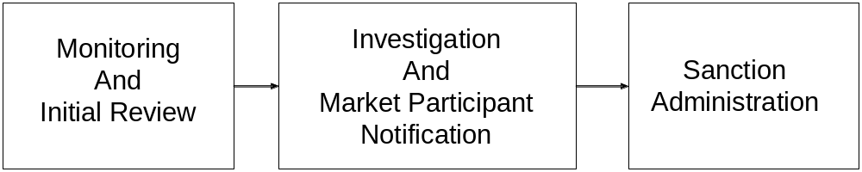Exhibit 3-1: Overview of Rules of Conduct Process

Monitoring & Initial Review
The CAISO continuously monitors for potential Rules of Conduct violations. A complete and detailed description of its monitoring practices is outside the scope of this BPM; however, at a high-level, the monitoring practices consist of the following:
- Reviews in response to referrals from other CAISO business units responsible for Grid and Market operations.
- Computer-automated review of market data.
Exhibit 3-2: Monitoring & Initial Review Process
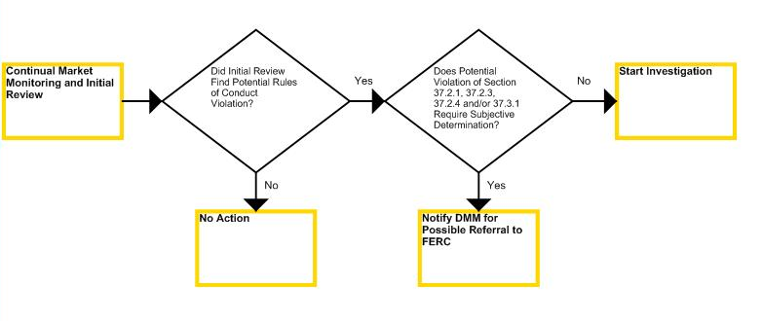

When a potential Rules of Conduct violation is identified, through either routine monitoring or referral, the CAISO initially reviews available information to determine if there is a reasonable potential that a violation occurred, making further investigation appropriate. In the course of collecting information, the CAISO may contact any Market Participant that is the subject of this initial review, except in cases such as potential violations of routine information submittal requirements, when individually contacting each Market Participant prior to sending a notice of investigation would not be practical.
Based on this initial review, the CAISO proceeds with one of three actions:
- Initiate an investigation, if the results of the initial review reveal that an enforceable Rules of Conduct violation may have occurred.
- Notify DMM if the conduct involves a potential violation of Sections 37.2.1, 37.2.3, 37.2.4 or 37.3.1. DMM then potentially refers the matter to FERC’s Office of Enforcement pursuant to DMM’s general obligation to refer Market Violations to the Office of Enforcement.
- No further action, if the initial review indicates a Rules of Conduct violation did not occur.

Referrals to FERC
Based on the results of its initial review, if the CAISO discovers that the circumstances preclude the objective determination of a Rules of Conduct violation, it refers the matter to FERC through DMM.

3.2.2 Notifying DMM of Potential Market Violations
Based on the results of its initial review, if CAISO business units discover a potential violation of Sections 37.2.1, 37.2.3, 37.2.4 or 37.3.1, DMM will be notified. Under Section 11.1 of Appendix P, DMM has a general obligation to refer to FERC suspected Market Violations, with the exception of Rules of Conduct violations that carry specified Sanctions administered by the CAISO. Where a CAISO business unit notifies DMM of a potential violation of Sections 37.2.1, 37.2.3, 37.2.4 or 37.3.1, DMM will refer the matter to FERC if DMM determines, in its sole discretion, that there is sufficient credible information to warrant further investigation by the Office of Enforcement.
Following a referral to FERC, DMM continues to notify and inform FERC of any information that it happens to learn of that may be related to the referral. In order to conform to policy guidelines established by FERC regarding enforcement of matters under FERC’s enforcement authority, once DMM makes a referral, it does not seek to collect any additional information related to the potential violation from Market Participants that are the subject of a referral. Notwithstanding the referral, DMM may continue its analysis of the same general type of behavior that was the subject of the referral, continue its ongoing monitoring functions and make recommendations to CAISO management, stakeholders, and FERC on tariff changes that may be appropriate.
DMM contacts Market Participants as part of its initial review of a matter before it formally refers a matter to FERC, and informs relevant Market Participants of any formal referral to FERC by providing a copy of the referral letter, with the exception of the circumstances described below.
DMM does not contact Market Participants or provide notification of a formal referral to FERC if doing so would potentially jeopardize FERC’s investigation. In addition, a Market Participant might be the subject of a referral to FERC, but not be contacted by or receive notice from DMM, if DMM refers certain behavior to FERC but lacks sufficient information to identify every Market Participant that may have engaged in the behavior. In that case, the referral would require DMM to cease its investigation, and it would not be able to identify and inform every Market Participant involved.
In addition to the formal referrals of potential violations described above, DMM also may provide FERC with market data regarding market behaviors that FERC is evaluating, or DMM may communicate with FERC staff regarding general market rule or performance issues being reviewed by DMM, typically involving a number of Market Participants. DMM typically does not inform Market Participants in these cases.

Investigation
If the initial review by the CAISO reveals that an objectively verifiable violation of the Rules of Conduct may have occurred, the CAISO more formally investigates the matter pursuant to the process described in this section and CAISO Tariff Section 37.8.3. Exhibit 3-3 describes the process used by the CAISO to investigate potential Rules of Conduct violations.
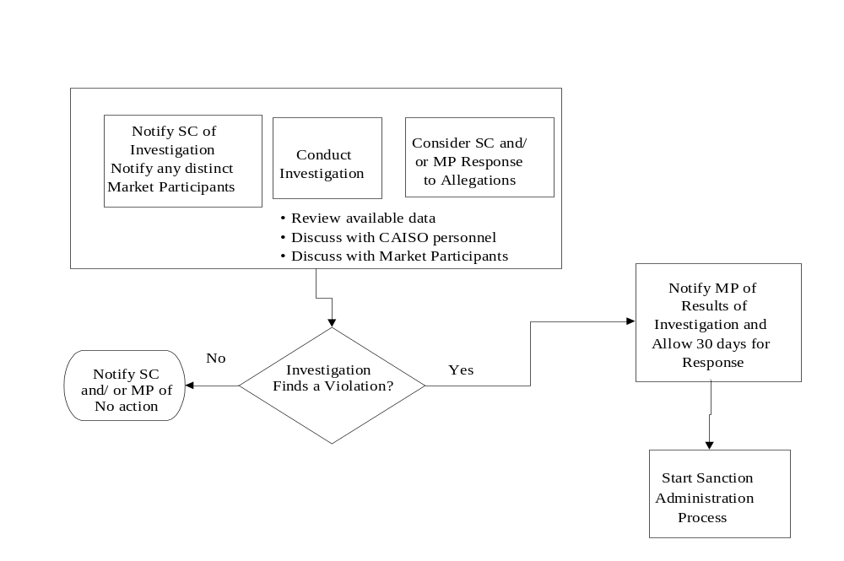
Exhibit 3-3: Investigation Process

When the CAISO begins an investigation into a potential Rules of Conduct violation, it reviews applicable information, notifies the relevant Market Participant of the investigation and provides an opportunity for Market Participants to respond to the allegations.
On completion of an investigation, the CAISO notifies relevant Market Participants of the results of its investigation. Market Participants have 30 calendar days to respond to those findings before the CAISO decides whether a Sanction is required.
If the investigation concludes that a Rule of Conduct was violated, the CAISO proceeds to administer Sanctions as described in Section 3.4. If the investigation does not identify a violation, the CAISO informs relevant Market Participants that no action is being taken by the CAISO.
Further details of this process are described in the following sections.

Conducting Investigation
CAISO Tariff 37.8.3, Investigation
When investigating potential Rules of Conduct violations, the CAISO seeks available facts, data, and other relevant information. This typically includes a review of the available data relevant to the matter including logs and electronic forms of available information – such as market data, discussions with relevant internal CAISO personnel and applicable Market Participants, and reviews of pertinent tariff provisions. The CAISO notifies applicable Market Participants and provides an opportunity for Market Participants to provide any relevant information, such as information that demonstrates that no violation occurred. In addition, the CAISO may require Market Participants to provide specific requested information to be used in its investigation, as described in Section 3.3.3, below. The CAISO maintains a record of the investigation including relevant information.

Notice of Investigation
CAISO Tariff 37.8.4, Notice
CAISO Tariff 37.8.6, Results of Investigation
CAISO Tariff 37.8.7, Statement of Findings and Conclusions
The CAISO makes two notifications to Market Participants during the investigation phase of administering a potential Rules of Conduct violation:
- The CAISO makes the first notification when it initiates an investigation. This notification states that the CAISO is undertaking an investigation of a potential Rules of Conduct violation, describes the allegation in sufficient detail to allow for a response by a Market Participant that is the subject of an investigation, and that the CAISO will consider any relevant information provided by the Market Participant by a specified date (typically 30 calendar days).
- The CAISO makes the second notification when it has completed its investigation, as described in Section 3.3.5 below (“Decision Regarding Violation and Notice”). As noted in Section 3.3.5, CAISO Tariff 37.8.7 requires that Market Participants are provided 30 calendar days to respond to these findings before the CAISO makes a final determination of whether a violation occurred and a Sanction is required by the Tariff.
The CAISO generally makes these notifications to the applicable Scheduling Coordinator. The CAISO also notifies any Market Participants that may be the subject of an investigation if: (1) the Market Participant is a separate entity from the Scheduling Coordinator that represents it with the CAISO; (2) the CAISO is able to identify the separate role of the Market Participant in the potential Rules of Conduct violation; and (3) the CAISO has access to the identity of, and contact information for, a Market Participant. Market Participants meeting these requirements likely have an existing contractual relationship with the CAISO as described in CAISO Tariff Section 37.8.4.
The CAISO makes these notifications through e-mail, to the Scheduling Coordinator’s appropriate business contact, if known, and in all cases to the primary representative of the Scheduling Coordinator or separate Market Participant as listed in the relevant contract agreements with the CAISO. Scheduling Coordinators may make a written request that the CAISO use a different contact, for matters under CAISO Tariff Section 37, than the person who is listed on the contract agreements with the CAISO.

Information Requests
CAISO Tariff 37.6.2, Investigation Information
CAISO Tariff 37.6.4, Review by FERC
The CAISO may request specific information that it requires as part of its investigation from Market Participants. CAISO Tariff Section 37.6.2 specifies that Market Participants are subject to financial penalty if they do not provide such requested information within the timeline specified by the CAISO. Market Participants that object to providing this information may – no later than the due date for the information – seek FERC’s immediate review of the obligation, pursuant to CAISO Tariff Section 37.6.4. The obligation to respond to the CAISO is tolled pending a decision from FERC.

Time Limitation
CAISO Tariff 37.10.1, Time Limitation
The CAISO begins its investigation within 90 calendar days of the CAISO’s discovery of the events subject to investigation. The CAISO may assess Sanctions under CAISO Tariff Section 37 up to one year after discovery of the events constituting a violation of the Rules of Conduct, but no later than three years after the date of the violation.

Decision Regarding Violation and Notice
CAISO Tariff 37.8.6, Results of Investigation
CAISO Tariff 37.8.7, Statement of Findings and Conclusions
At the conclusion of its investigations, the CAISO determines whether a violation occurred. If there was a violation, then the CAISO notifies the Market Participant that its investigation has found a violation, and provides the Market Participant a description of the particular findings and conclusions. A Market Participant has 30 calendar days to respond to these findings before the CAISO makes a final determination of whether a violation occurred and a Sanction is required by the Tariff.

Sanction Administration
Where the CAISO has determined that a violation occurred, has notified a Market Participant of the results of its investigation, has allowed the Market Participant 30 calendar days to respond, and has made a final determination that a Rules of Conduct violation occurred, then the CAISO administers any applicable Sanction through a process that includes the following steps:
- Determine the Sanction.
- Notify the Market Participant prior to invoicing a financial penalty.
- Invoice the financial penalty through the CAISO Settlement process.
- Suspend assessment of the financial penalty, where the Market Participant appeals the penalty to FERC and the Market Participant disputes the Settlement Statement containing the penalty.
Exhibit 3-4 describes the process the CAISO uses to administer Sanctions. The CAISO first determines the appropriate Sanction in accordance with the CAISO Tariff and then notifies the Scheduling Coordinator/Market Participant of the Sanction along with its findings and conclusions. If the Sanction is a financial penalty, it is subsequently invoiced through the CAISO Settlement Process.

Exhibit 3-4: Sanction Administration Process
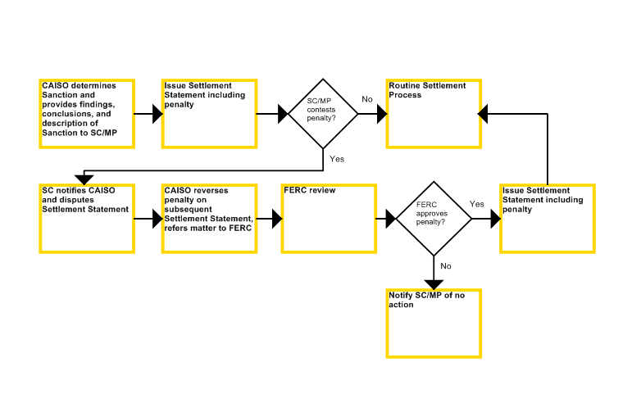

Market Participants have the right to appeal Sanctions imposed by the CAISO pursuant to the Rules of Conduct. Where a Market Participant wishes to dispute a Sanction, the applicable SC disputes the Settlement Statement containing the penalty and the CAISO will reverse the charge until FERC rules on the appeal.
Further details of this process are provided in the following sections.

Determination of Sanctions
CAISO Tariff Section 37.9, Administration of Sanctions
The CAISO determines the appropriate Sanction for a Rules of Conduct violation pursuant to the criteria specified in CAISO Tariff 37. The criteria differ for violations of the different Rules of Conduct. By way of example, the Sanction depends on variables such as the number of previous violations or the number of days that information is late. For certain violations, penalties are increased if the violation occurs during a System Emergency, as described below. Sanctions may include a financial penalty or a warning letter.
Financial penalty amounts are tripled for violations of CAISO Tariff Section 37.4 (Comply with Availability Reporting Requirements) if the violation occurred during a System Emergency. The CAISO determines that a System Emergency existed when a Rules of Conduct violation occurred within the time period listed as part of a System Emergency or Transmission Emergency notice issued by the CAISO.
Violations of 37.5.2, Inaccurate Meter Data, may involve a “market adjustment”, which is a charge separate from any financial penalty amount that approximates the value of inaccurately reported Meter Data. (See CAISO Tariff Sections 37.5.2 and 37.11).
When a separate Market Participant, distinct from the Scheduling Coordinator representing the Market Participant, is solely responsible for a Rules of Conduct violation, the applicable Sanction specified in CAISO Tariff Section 37 is levied against the responsible Market Participant through the Scheduling Coordinator. When the CAISO cannot delineate responsibility for a Rules of Conduct violation between a Scheduling Coordinator and a separate Market Participant represented by the Scheduling Coordinator, the applicable Sanction is levied against the Scheduling Coordinator and the Market Participant jointly through the Scheduling Coordinator.

Notification of Affected Parties
CAISO Tariff Section 37.8.7, Statement of Findings and Conclusions
CAISO Tariff Section 37.9, Administration of Sanctions
Once the CAISO has determined an appropriate Sanction, it notifies the Market Participant of its findings and conclusions. If the Sanction is a financial penalty, then prior to administering the penalty through the Settlement process the CAISO also provides the following information to the applicable Scheduling Coordinator and any separate Market Participant the Scheduling Coordinator represents that is liable for the penalty:
- Description of the penalty, including identity of the Market Participant(s) that committed the violation and the amount of the penalty.
Specification of whether penalty is modified pursuant to CAISO Tariff Section 37.4.4.

Settlement
Penalties for Rules of Conduct violations, as well as market adjustments for inaccurate meter data, are invoiced through the CAISO Settlement Process and will appear on the next relevant Settlement Statement. Market Participants may appeal penalties assessed by the CAISO to FERC. The CAISO holds the proceeds of penalties collected in a trust account, allocating them after the completion of the calendar year during which they were assessed to Market Participants that have not incurred a penalty during that calendar year under CAISO Tariff Section 37, in proportion to GMC paid.
Violations of CAISO Tariff Section 37.5.2, Inaccurate Meter Data, may include a market adjustment, which is a charge under CAISO Tariff Section 37 to provide an approximate settlement for the value of the inaccurate Meter Data. The market adjustment is calculated based on the MWh value of the inaccurate Meter Data in each hour of the applicable period and the applicable LMP. The CAISO allocates market adjustment proceeds to Scheduling Coordinators, in proportion to average UFE charges for the corresponding UDC territory during the period of the inaccurate Meter Data. The allocation is included on the Settlement Statements for the same Trading Day that the CAISO includes the market adjustment charge on the Settlement Statement.

Settlement Statements
Charges and allocations made pursuant to CAISO Tariff Section 37 are ordinarily made by CAISO once a month, and ordinarily are included as a special adjustment on a Settlement Statement. These charges and allocations appear under the following Settlement Statement Charge Codes (see also related Settlement BPMs):
- CC 1591 CAISO Tariff Section 37 Penalty Charge

- CC 1592 CAISO Tariff Section 37 Penalty Allocation Payment (i.e. end of year allocation of penalty funds, as described in Section 3.4.5)

- CC 1593 CAISO Tariff Section 37 Charge/Allocation for Inaccurate Meter Data (i.e. inaccurate Meter Data “market adjustment” charge, as described in Section 3.4.4.)
As described in Section 3.4.2, the CAISO provides a notification to the applicable Scheduling Coordinator, and any separate Market Participants, before a penalty is included on a Settlement Statement. This notification includes a description of the penalty, including the identity of any separate Market Participants that committed the violation, the amount of the penalty, and specification of any modifications.
The following data related to a charge or allocations appear on Settlement Statements in the appropriate Billing Determinant by Charge Code:
- ATTRIBUTE1 field – Business Associate ID.
- ATTRIBUTE9 field –Pass Through Bill (PTB) ID.
- DATA fields – Total amount of penalty, “market adjustment” charge, or allocation by settlement interval.
- PTB_COMMENTS field –
- PENALTY - “RoC ID [unique identification number assigned to the violation] per letter dated [date of letter], Rules of Conduct penalty and/or charge issued for event on Trade Date [trade date] in accordance with CAISO Tariff Section[s] [relevant tariff section included]. When a separate Market Participant, distinct from the Scheduling Coordinator representing the Market Participant, is solely responsible for a Rules of Conduct violation, the “PTB_COMMENT” field also includes the text “Penalty issued to [name of Scheduling Coordinator] in behalf of [name of Market Participant].”
- ALLOCATION – “Allocation of Rules of Conduct penalty fund in accordance with CAISO Tariff 37.9.4 as per Market Notice dated [date of Market Notice].

Scheduling Coordinator Appeals to FERC
CAISO Tariff Section 37.8.10, Review of Determination
Penalties assessed under CAISO Tariff Section 37 may be appealed to FERC as outlined in CAISO Tariff section 37.8.10. If a Scheduling Coordinator or a separate responsible Market Participant desires to appeal the CAISO’s determination that the tariff requires a financial penalty for a particular matter, the applicable Scheduling Coordinator must dispute the Settlement Statement that includes the penalty charge within the dispute timeline specified in CAISO Tariff Section 11.29.8.2. In addition, a Scheduling Coordinator may dispute a penalty if it is unable to obtain payment from a separate Market Participant, as described in Section 3.4.3.3. A Scheduling Coordinator that appeals to FERC is requested to direct service of its appeal to both the Director of Market Services at the CAISO as well as to the CAISO Legal Department via e-recipient@caiso.com. If a Scheduling Coordinator disputes a Rules of Conduct penalty, but does not make a timely appeal to FERC, the CAISO will deny the dispute.
If FERC denies an appeal, the CAISO will reassess the penalty on a subsequent Settlement Statement, after notice to the relevant Scheduling Coordinator and any applicable separate Market Participants has been given.

Nonpayment by Market Participant
CAISO Tariff Section 37.9.3.3, Other Responsible Party
Where a party or parties other than the Scheduling Coordinator is responsible for the conduct giving rise to a penalty charge, and where the Scheduling Coordinator bears no responsibility for the conduct, such other party or parties are ultimately liable for the penalty. If the Scheduling Coordinator is unable through reasonable efforts to obtain payment from a separate Market Participant, the Scheduling Coordinator should notify the CAISO. If the CAISO finds that the separate party (or parties) is solely responsible for the penalty, then the Scheduling Coordinator should dispute the Settlement Statement that includes the penalty. In the event of such a dispute, the CAISO notifies FERC and reverses the charge on a subsequent Settlement Statement. The CAISO may refuse to offer further service to any responsible party that fails to pay a penalty by providing notice to the relevant Scheduling Coordinator – in such case the relevant Scheduling Coordinator will be responsible for any subsequent penalties assessed on account of such responsible party.

Disposition of Sanction Proceeds
CAISO Tariff Section 37.9.4, Disposition of Proceeds
Payments received for Rules of Conduct penalties are credited to an interest bearing trust account where they are held until allocated. CAISO distributes these funds to Market Participants, through Scheduling Coordinators, that were not assessed a financial penalty pursuant to CAISO Tariff Section 37 during the calendar year.
The penalty funds are distributed by CAISO as follows:
- After the end of each calendar year, the CAISO requests that each Scheduling Coordinator issued a penalty on a Settlement Statement for a Trading Day during that calendar year provide a listing of the amount of GMC paid by each Market Participant that the Scheduling Coordinator represented during that year and the GMC paid by the Scheduling Coordinator itself for services provided on its own behalf. The total amount assigned to all Market Participants shall equal the total GMC paid by that Scheduling Coordinator.
- The CAISO calculates the payment due each Scheduling Coordinator as a pro-rata share of the total amount in the trust account determined by the ratio of the GMC paid by the Scheduling Coordinator on behalf of eligible Market Participants to the total GMC paid by all Scheduling Coordinators on behalf of eligible Market Participants. The payment due to each Scheduling Coordinator shall not exceed the GMC actually paid by all eligible Market Participants represented by that Scheduling Coordinator.
- The CAISO requests and obtains FERC approval of its determination of eligible Market Participants and their respective shares of the trust account proceeds.
- Upon FERC’s approval, the CAISO includes the payment on Settlement Statements, as Charge Code 1592. Each Scheduling Coordinator is responsible for distributing payments to the eligible Market Participants it represents in accordance with the FERC approved determination of eligible Market Participants and their respective shares of the trust account proceeds.
A simplified example of the penalty distribution methodology, assuming $1,000 in penalties were collected over the calendar year, is as follows:
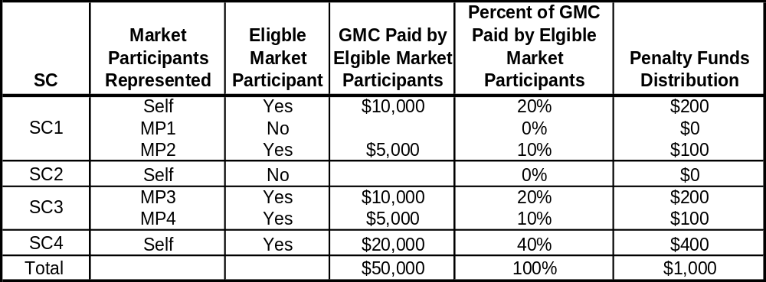

Record Keeping
CAISO Tariff Section 37.8.9, Record of Investigation
The CAISO retains copies of the notifications issued to Market Participants as long as required by the CAISO Record Retention Policy. In addition, when an investigation results in a Sanction, the CAISO maintains its record of investigation until its decision has been finally reviewed, or until the period for seeking review has expired. The record of investigation includes all data that the CAISO considered relating to the following issues: a) whether the Rules of Conduct were violated; b) any information that the Market Participant provided to indicate that a violation did not occur; and c) whether any separate Market Participant was responsible for the violation.

Provided the CAISO has sufficient objective information to identify and verify the responsibility of such Market Participants.
The calculations for the “Market Adjustment” charges and allocations are defined in CAISO Tariff Section 37.11.
Under Section 37.9.3.3, the Scheduling Coordinator also has the option of netting its invoice by the amount of the penalty in question. However, where the CAISO reverses the charge, such netting would not be permitted because the Scheduling Coordinator would then be netting its invoice of a charge that no longer appeared on its invoice.

